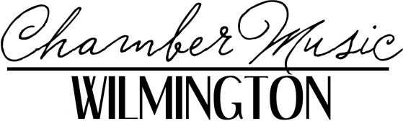

FOR IMMEDIATE RELEASE
Media Contact: Richard Wenz
Tel. (949) 606-5887
Email: chambermusicwilmington@gmail.com
Photo and PR as Word: www.chambermusicwilmington.org/press
Photo: https://drive.google.com/file/d/13v6khMlr-u-kkhQW_F69uqonOBsjeN0z/view?usp=sharing
Media: https://www.merztrio.com/media

Chamber Music Wilmington Announces
Merz Trio Back by Popular Demand
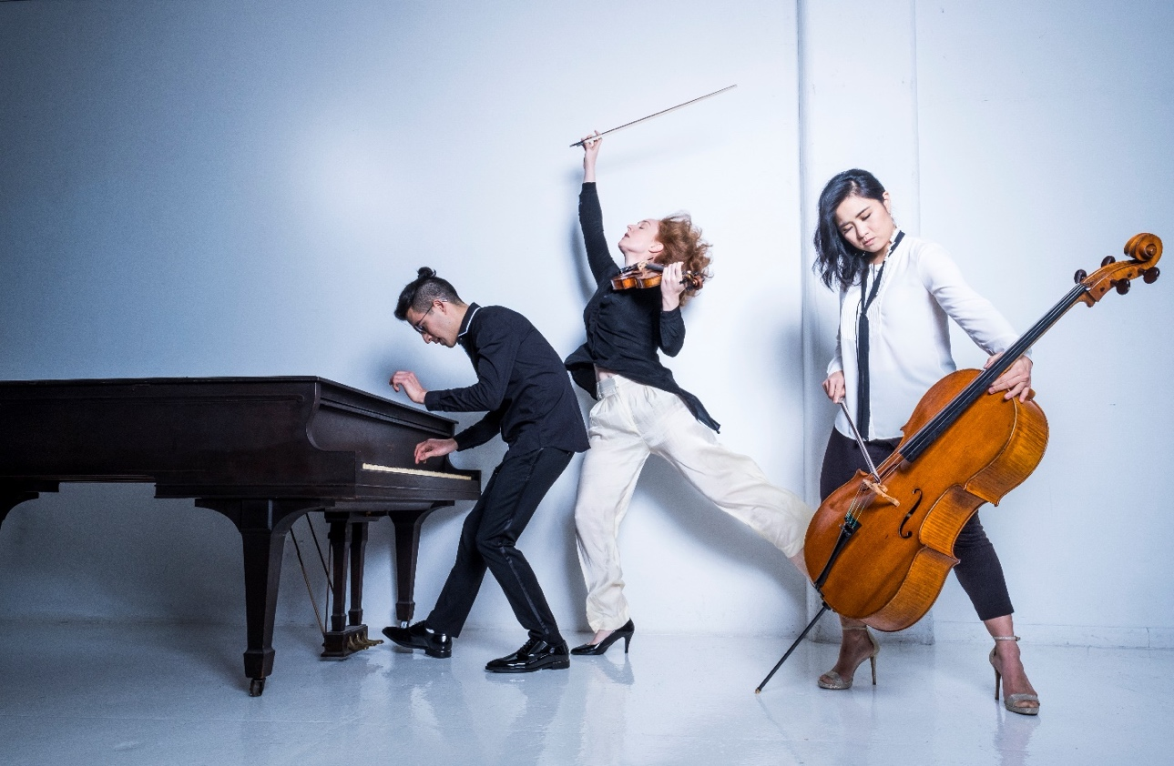
Merz Trio. From left: Lee Dionne, piano; Brigid Coleridge, violin; Julia Yang, cello.

(Wilmington, NC) Following your acclaim of their September 2021 performance, the Merz Trio has returned to our concert stage on Sunday November 6, 2022, at UNCW’s Beckwith Recital Hall.

Together, they are humbled to have been recognized as Winners of the 2019 Concert Artists Guild and Fischoff Competitions, and the 2018 Chesapeake Competition. They have been encouraged in their explorations by the New England Conservatory in Boston and its visionary faculty. They are grateful, too, for other homes around the world: Yellow Barn, Snape Maltings, Avaloch Farm

Institute, the Lake Champlain, Olympic, and Chesapeake Music Festivals, and hundreds of welcoming concert venues and hosts around the US, Australia, and the UK.

Merz is a nonce-word coined by the one-of-a-kind German artist Kurt Schwitters, a Dada-inspired multimedia polymath who sought a term uniquely fitting his art. The name Merz speaks to connection, to sharing, to possibility.

The Trio love music of all varieties, literature, theatre, cooking, dance, running, unnecessarily snobbish ideas about beverages: messiness. They play in living rooms and large halls; galleries and schools; black box theaters and crypts. There are very few places they don’t feel at home.

They love to create original inter-disciplinary projects, sometimes just with themselves and their extra-musical interests, more often with inspiring and generous artists. This upcoming performance will feature a collaboration with Chamber Music Wilmington’s artistic Director Oskar Espina-Ruiz who will accompany on clarinet. They have also brought their music into conversation with dancers, directors, chefs, sommeliers, puppeteers, and graphic designers, and each time they collaborate, they understand the music that they play differently.

The Trio’s debut CD, Ink, produced with assistance from indiegogo.com, centers on Ravel’s iconic piano trio, interwoven with the Trio’s new arrangements of works by Lili Boulanger, Nadia Boulanger, Josephine Baker, and Claude Debussy. Rounding out the album is the music of Mélanie Bonis, a Ravel-inspired composition by Merz pianist Lee Dionne, and readings of texts by Parisian writers and poets.

The Merz Trio believe that art happens where people are, and they hope you'll come along for the ride.

All of Chamber Music Wilmington’s 2022-2023 concerts starts at 4:00 pm ET on Sundays at Beckwith Recital Hall. Tickets are available at the UNCW Box Office, tel. (910) 962-3500 and uncwarts.universitytickets.com. For more information, please visit chambermusicwilmington.org or email us at chambermusicwilmington@gmail.com.
About Chamber Music Wilmington

Chamber Music Wilmington brings professional, live chamber music to the Cape Fear Region. We produce classical music performances to enrich and engage audiences of the Region, with close attention to the musical tastes of our audiences. We promote enthusiasm for chamber music by outreach to the community in a variety of settings. CMW is committed to cultivating community engagement and audience diversity through the following initiatives.

CONCERT SERIES: CMW’s four-concert program features award-winning national and international artists performing chamber music from all eras.

COMMUNITY OUTREACH: CMW supports young artists by offering free educational enrichment opportunities, providing artists of all ages and levels a chance to work with award-winning musicians in a masterclass environment.

ENGAGEMENT: CMW connects the community, providing a variety of music-making opportunities for all ages and levels through music meet-ups and ‘jams’, amateur chamber music ensembles, and Instrument Petting Zoos.

ENRICHMENT: CMW partners with Wilmington’s public radio station 92.7 Classical WHQR to present interviews and live broadcasts with visiting artists as well as a lunch-and-learn series, “A Little Lunch Music."

PARTNERSHIP: CMW partners and collaborates with the Cape Fear Arts Council, the NC Arts Council, local educational institutions, and other performing and visual arts organizations in the Cape Fear Region.

# # #

Chamber Music Wilmington, P.O. Box 428, Wilmington, NC 28402

